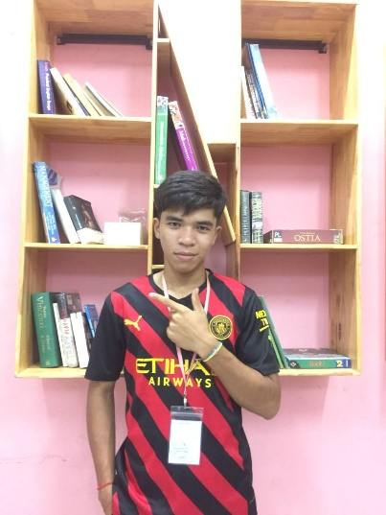

VOEUNCHANTHOU

## PROFILE

Lorem ipsum dolor sit amet, consectetuer adipiscing elit. Maecenas porttitor congue massa. Fusce posuere, magna sed pulvinar ultricies, purus lectus malesuada libero, sit amet commodo magna eros quis urna. Nunc viverra imperdiet enim. Fusce est. Vivamus a tellus.

Contact

# Phone

009-008-9111

# Email

[chanthou.voeun@mail.com](mailto:chanthou.voeun@mail.com)

# Address

168 Anywhere St. Any City

Expertise

* strong Oraganizational Skill
* Time Management
* Communication Skills
* Good Computer Skills

Educations

**bachelor or science**

**2015-2017**

university of liceria

**High school diploma**

**2013-2015**

Larana School Academy

## WORK EXPERIENCE

# VIRTUAL ASSISTANT, SALFORD & CO, 2019-2022

* Responding to Email and Phone Calls
* Schedulin Meeting
* Booking Travel and Accommodation
* Maintaining Contact Lists
* Conductina Market Research
* Assigned Presentations Creating
* Employees Answering Administative Questions

# ADMINISTSTRATOR, THYNK UNLIMITED 2017-2019

* Answer incoming calls and receive message
* Handing email inquiries
* Appointment management and scheduling
* data collection
* Stationery general office administration
* Travel arangements and employee and customer accommodation
* Organization or internal and external events